Durham Volunteer Police Cadets

We wanted to share with you what our Durham Cadets have been up to since Easter this year.

The junior cadets had a great time at their residential at Newby Wiske ran by PGL. Ironically Newby Wiske Hall was the old Police HQ for North Yorkshire Police. Our staff were privileged to be given a tour of the old hall whilst the cadets pushed themselves out of their comfort zones joining in the many activities on offer. A brilliant few days

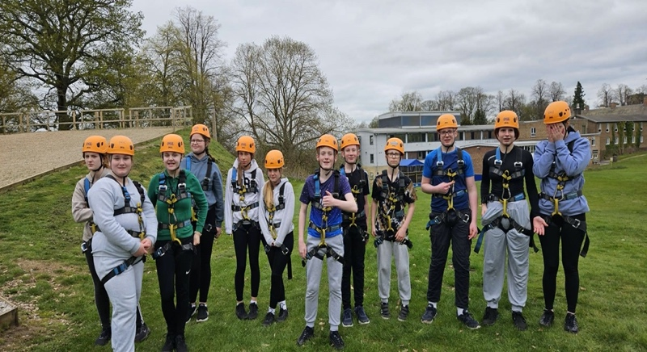

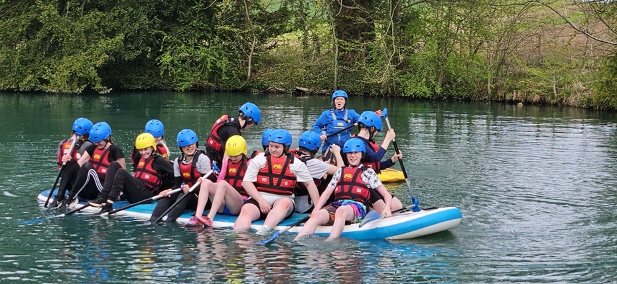

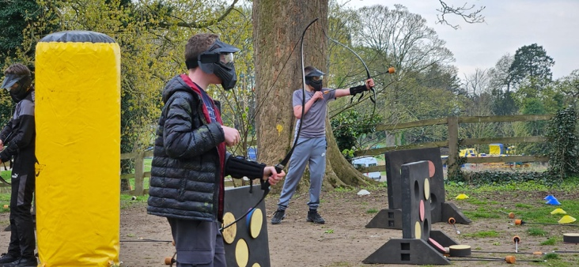

Casualty Simulation Exercise
Cadets had the fantastic opportunity to be part of a casualty simulation exercise based on a train derailment. This involved Penrith Mountain Rescue and the Eden Valley Railway. They had an amazing experience and can’t wait to help out next year!

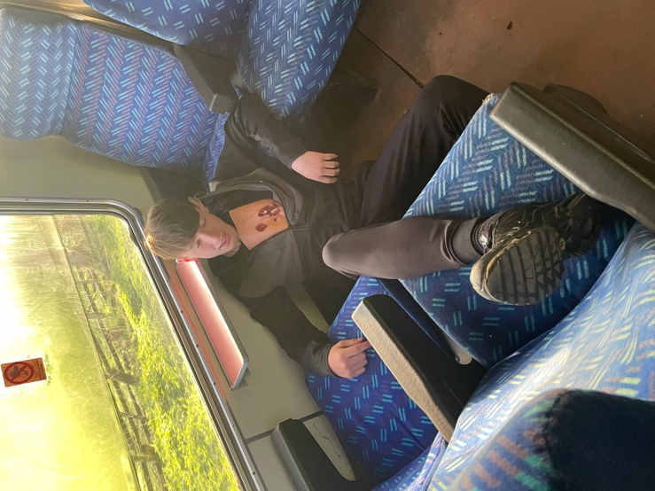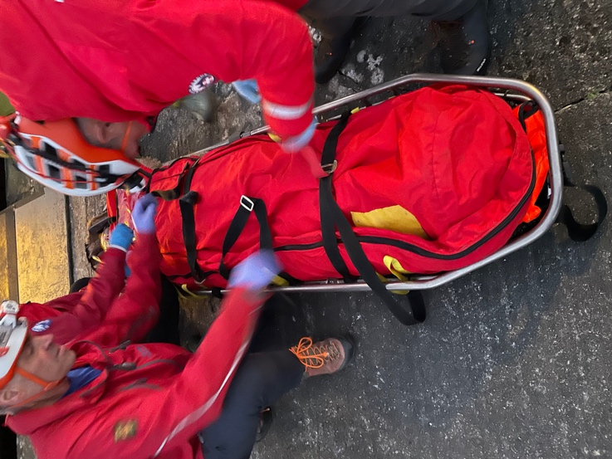

Bronze Duke of Edinburgh Qualifying Expedition
In May two of our Bronze Duke of Edinburgh groups embarked on their expedition, 2 days and one night. Starting at Penshaw Monument navigating to their camp site (a scout camp) approx. 8 miles from the start. The following day they completed their route, finishing at High Haswell. They could see Penshaw monument in the distance and couldn’t believe they had walked that far! An awesome achievement. Well done!

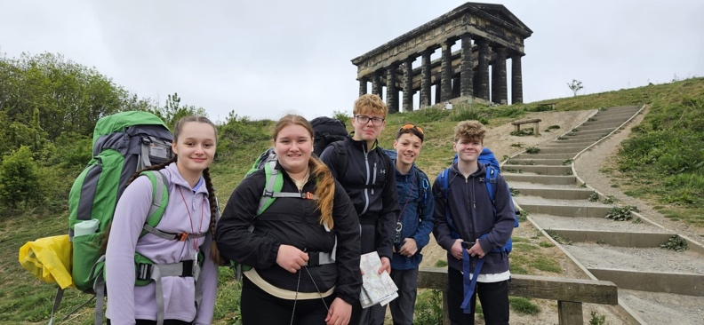 | 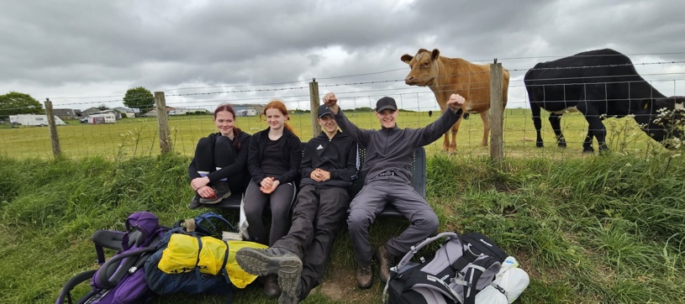

Super Hero Charity Event
In June the cadets were asked to assist The Heel to Toe Childrens Cancer Charity with their annual Super Hero Walk. Our cadet role was to line the route along with the Air Cadets to support and cheers all those completing the sponsored walk. There were some inspiring children taking part and the cadets formed a guard of honour to cheer them on.

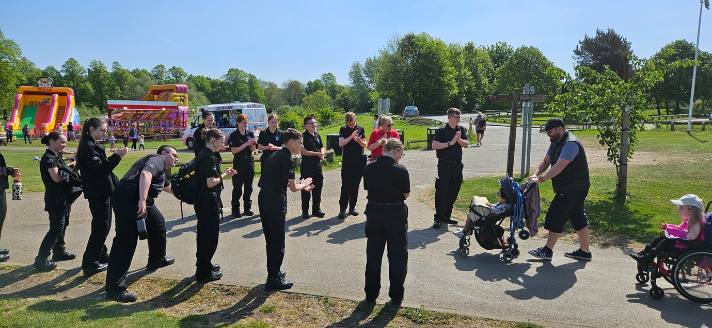

Operation Hawkeye  Cadets assisted PCSO’s from Bishop Auckland in Operation Hawkeye in an attempt to tackle vehicle crime in the neighbourhood. They were checking for insecure vehicles and if found unlocked, contacting and speaking to the owner. | 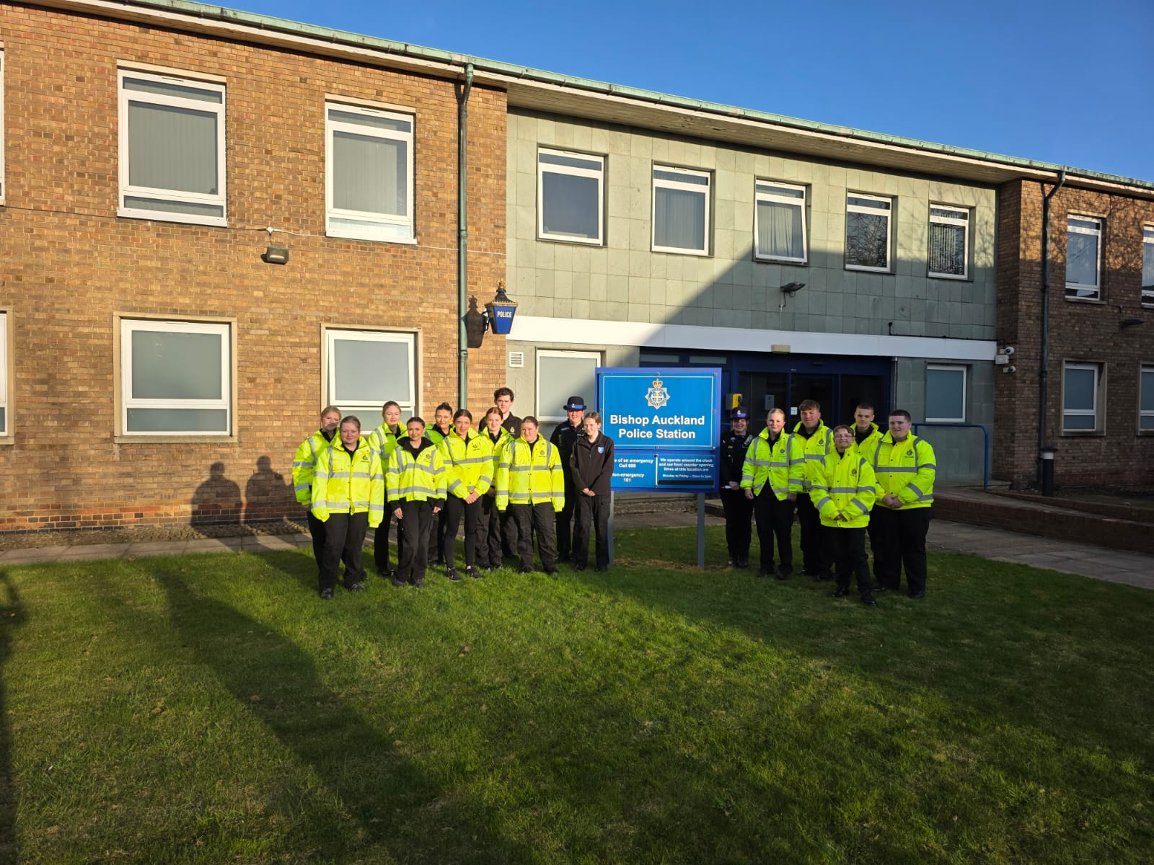

To mark the end of the cadet year we celebrated at Police HQ with a BBQ and games night. A chance for all the cadets groups to meet up and enjoy an evening of games and food.

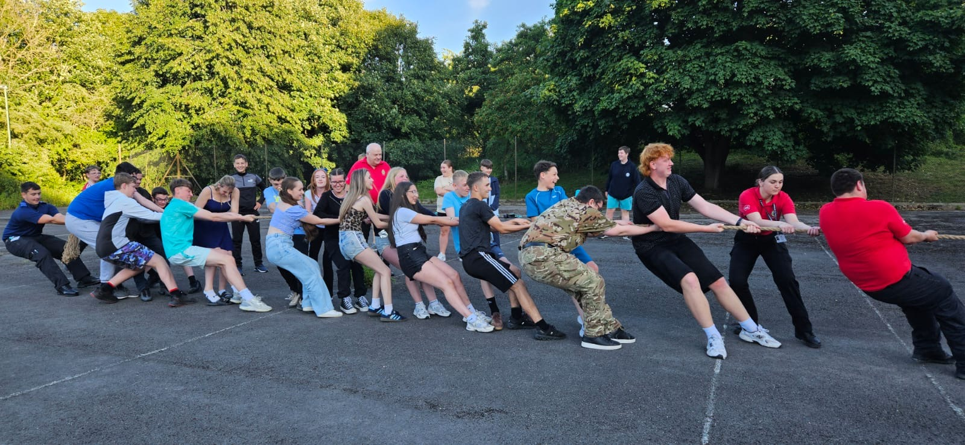

The following week was our Annual Presentation Evening held at the Durham Centre. Friends and family came along to celebrate the achievements of all of our cadets. There were awards for Smartest on Parade, Fitness awards, Highest Attendance, Duke of Edinburgh as well as commendations and the prestigious Norma Cowen Award awarded to Cadet Adam Burton. We were delighted to welcome Mick Urwin from The National VPC who kindly presented some of the awards.

